Multistage Docker build
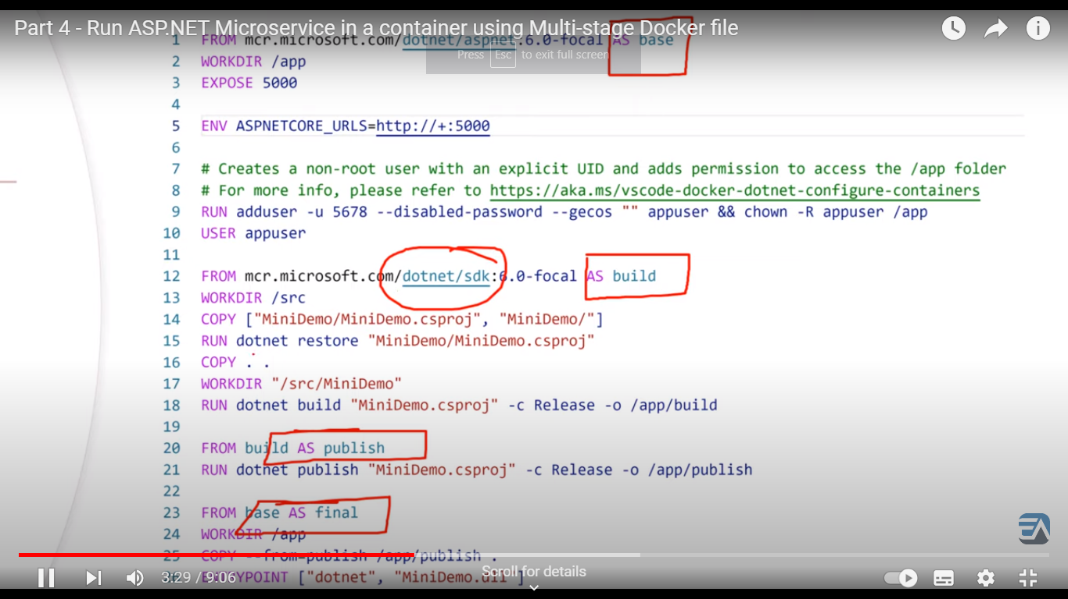

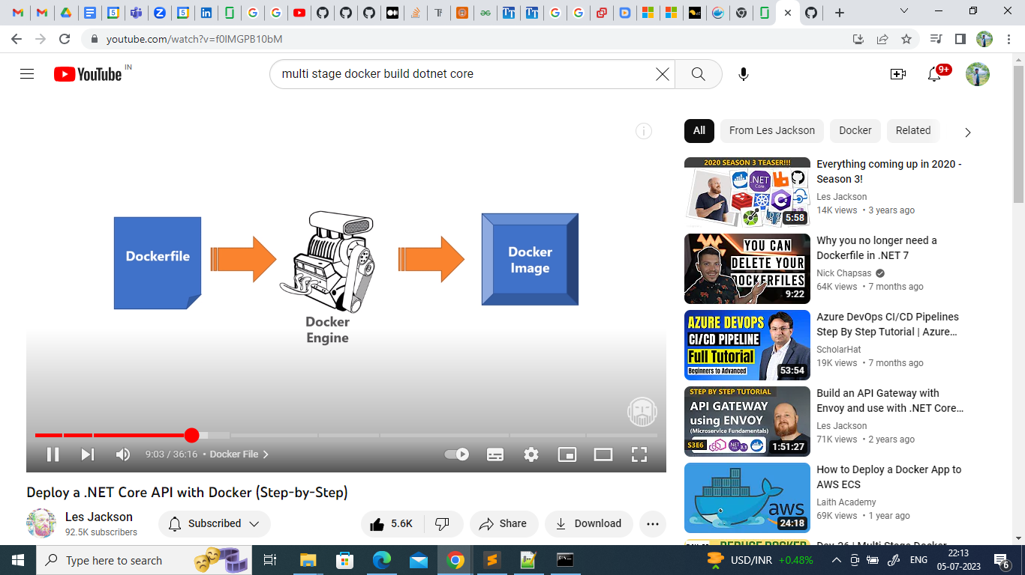

Azure Event Hub

https://www.youtube.com/watch?v=Dc3P27BsK3E&t=313s

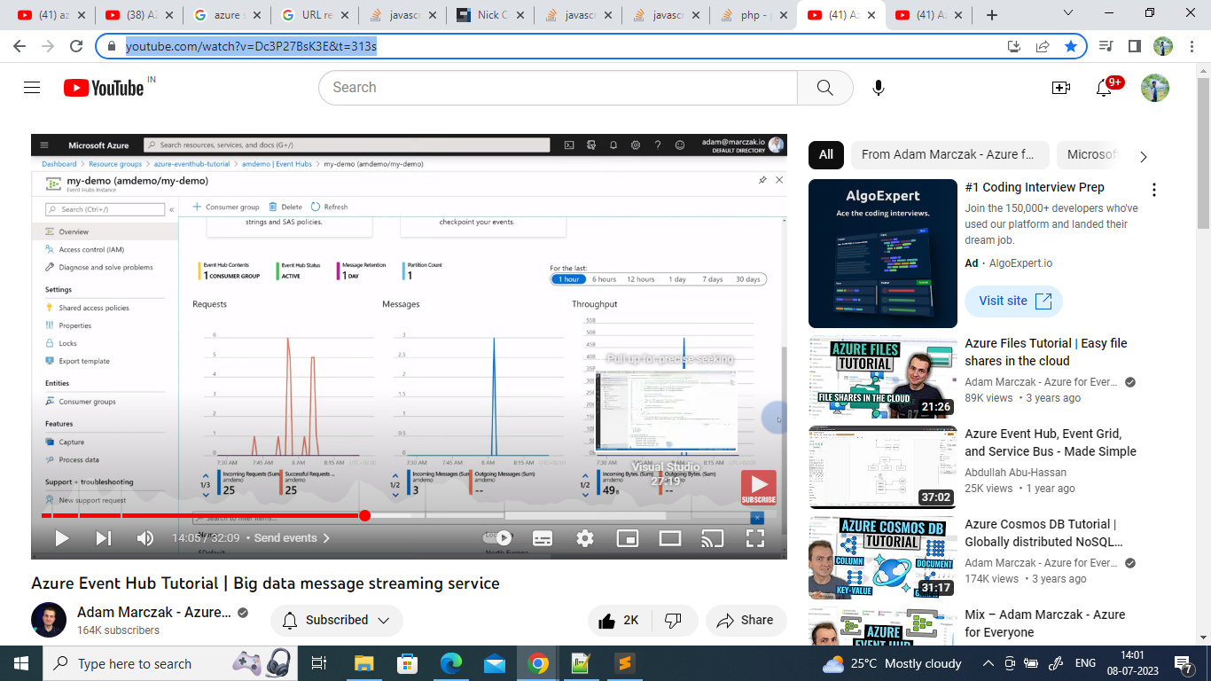

https://www.youtube.com/watch?v=hqtUZNmVVdA

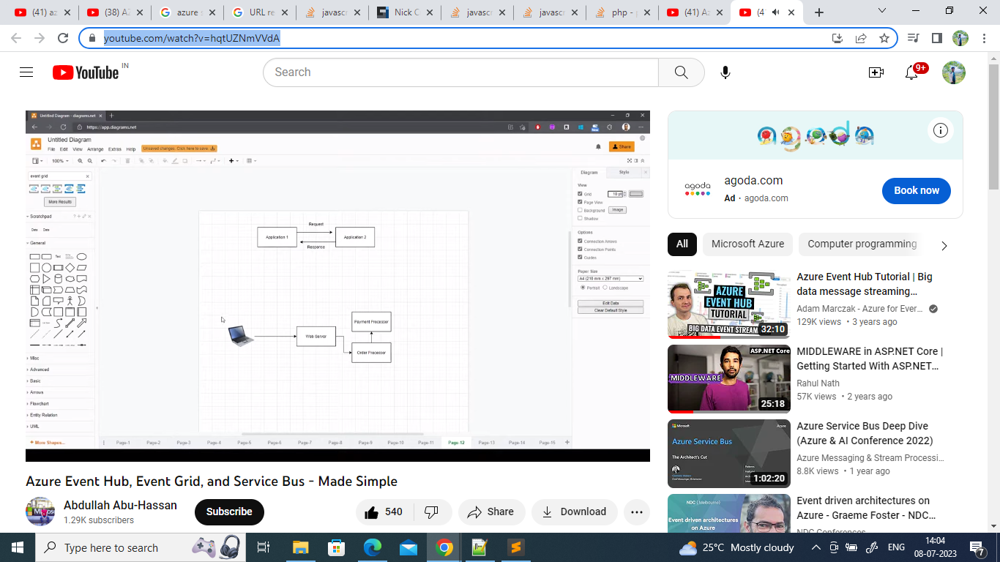

Each Pod has its own IP address

EKS and Application security

AWS IAM and K8s RBACnamespaces

Kubernetes namespaces

